5G/6G COMMUNICATION SYSTEM
DESIGN TASK
NAME: A. PRABHAKARAN
REG.NO:192412577
COURSE CODE: ECA5641
DATE:10/08/2026
Q1. Propose an optimized fronthaul communication model.
AIM:
To design and simulate an optimized 5G fronthaul communication model by analyzing the effects of traffic load on latency, throughput, bandwidth utilization, and transmission efficiency using MATLAB.
PROGRAM CODE:
clc;
clear;
close all;
% Traffic load in Gbps
traffic_load = 1:1:10;
% System parameters
bandwidth = 10; % Available bandwidth in Gbps
base_latency = 2; % Base latency in ms
% Conventional fronthaul
latency_conventional = base_latency + 2*traffic_load;
throughput_conventional = traffic_load .* ...
(1 - 0.04*traffic_load);
% Optimized fronthaul
latency_optimized = base_latency + 0.8*traffic_load;
throughput_optimized = traffic_load .* ...
(1 - 0.015*traffic_load);
% Bandwidth utilization
utilization = (traffic_load / bandwidth) * 100;
% Efficiency
efficiency_conventional = ...
(throughput_conventional ./ traffic_load) * 100;
efficiency_optimized = ...
(throughput_optimized ./ traffic_load) * 100;
% Plot results
figure;
subplot(2,2,1)
plot(traffic_load,latency_conventional,'--o','LineWidth',2)
hold on
plot(traffic_load,latency_optimized,'-s','LineWidth',2)
xlabel('Traffic Load (Gbps)')
ylabel('Latency (ms)')
legend('Conventional','Optimized')
title('Latency Comparison')
grid on
subplot(2,2,2)
plot(traffic_load,throughput_conventional,'--o','LineWidth',2)
hold on
plot(traffic_load,throughput_optimized,'-s','LineWidth',2)
xlabel('Traffic Load (Gbps)')
ylabel('Throughput (Gbps)')
legend('Conventional','Optimized')
title('Throughput Comparison')
grid on
subplot(2,2,3)
plot(traffic_load,utilization,'LineWidth',2)
xlabel('Traffic Load (Gbps)')
ylabel('Bandwidth Utilization (%)')
title('Bandwidth Utilization')
grid on
subplot(2,2,4)
plot(traffic_load,efficiency_conventional,'--o','LineWidth',2)
hold on
plot(traffic_load,efficiency_optimized,'-s','LineWidth',2)
xlabel('Traffic Load (Gbps)')
ylabel('Efficiency (%)')
legend('Conventional','Optimized')
title('Efficiency Comparison')
grid on
OUTPUT:
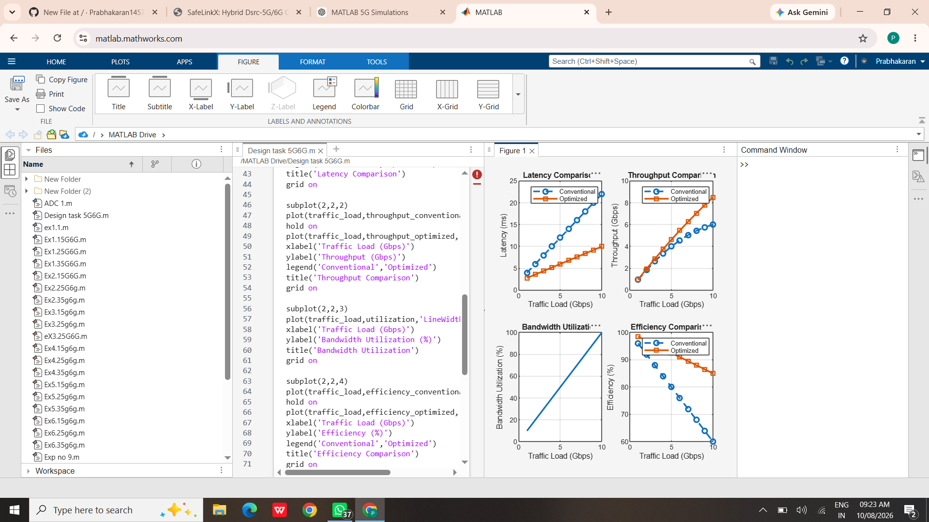
RESULT:
The optimized fronthaul communication model was successfully designed and simulated using MATLAB. The results showed that the optimized model achieved lower latency, higher throughput, and improved transmission efficiency compared with the conventional fronthaul model.
Q2. Design of a Satellite-Assisted Communication Model Using Low Earth Orbit Satellite for Remote Wireless Coverage

AIM:
To design and simulate a Low Earth Orbit (LEO) satellite-assisted communication model for providing wireless coverage to remote areas and analyze the effects of satellite distance on propagation delay, received signal power, and coverage.

PROGRAM CODE:
clc;
clear;
close all;
% LEO satellite parameters
h = 550; % Satellite altitude in km
fc = 2; % Carrier frequency in GHz
Pt = 30; % Transmitted power in dBm
Gt = 20; % Transmitter antenna gain in dBi
Gr = 20; % Receiver antenna gain in dBi
% Distance from remote user to satellite
distance = 550:50:1500; % km
% Speed of light
c = 3e8;
% Convert distance to meters
d = distance * 1000;
% Frequency in Hz
f = fc * 1e9;
% Free-space path loss
FSPL = 20*log10(d) + ...
20*log10(f) - ...
20*log10(c);
% Received power
Pr = Pt + Gt + Gr - FSPL;
% Propagation delay
delay = d / c * 1000; % milliseconds
% Coverage model
coverage = pi * distance.^2;
% Plot results
figure;
subplot(2,2,1)
plot(distance,FSPL,'LineWidth',2)
xlabel('Satellite Distance (km)')
ylabel('Path Loss (dB)')
title('LEO Satellite Path Loss')
grid on
subplot(2,2,2)
plot(distance,Pr,'LineWidth',2)
xlabel('Satellite Distance (km)')
ylabel('Received Power (dBm)')
title('Received Signal Power')
grid on
subplot(2,2,3)
plot(distance,delay,'LineWidth',2)
xlabel('Satellite Distance (km)')
ylabel('Propagation Delay (ms)')
title('Propagation Delay')
grid on
subplot(2,2,4)
plot(distance,coverage,'LineWidth',2)
xlabel('Satellite Distance (km)')
ylabel('Coverage Area (km^2)')
title('Remote Coverage')
grid on
OUTPUT:
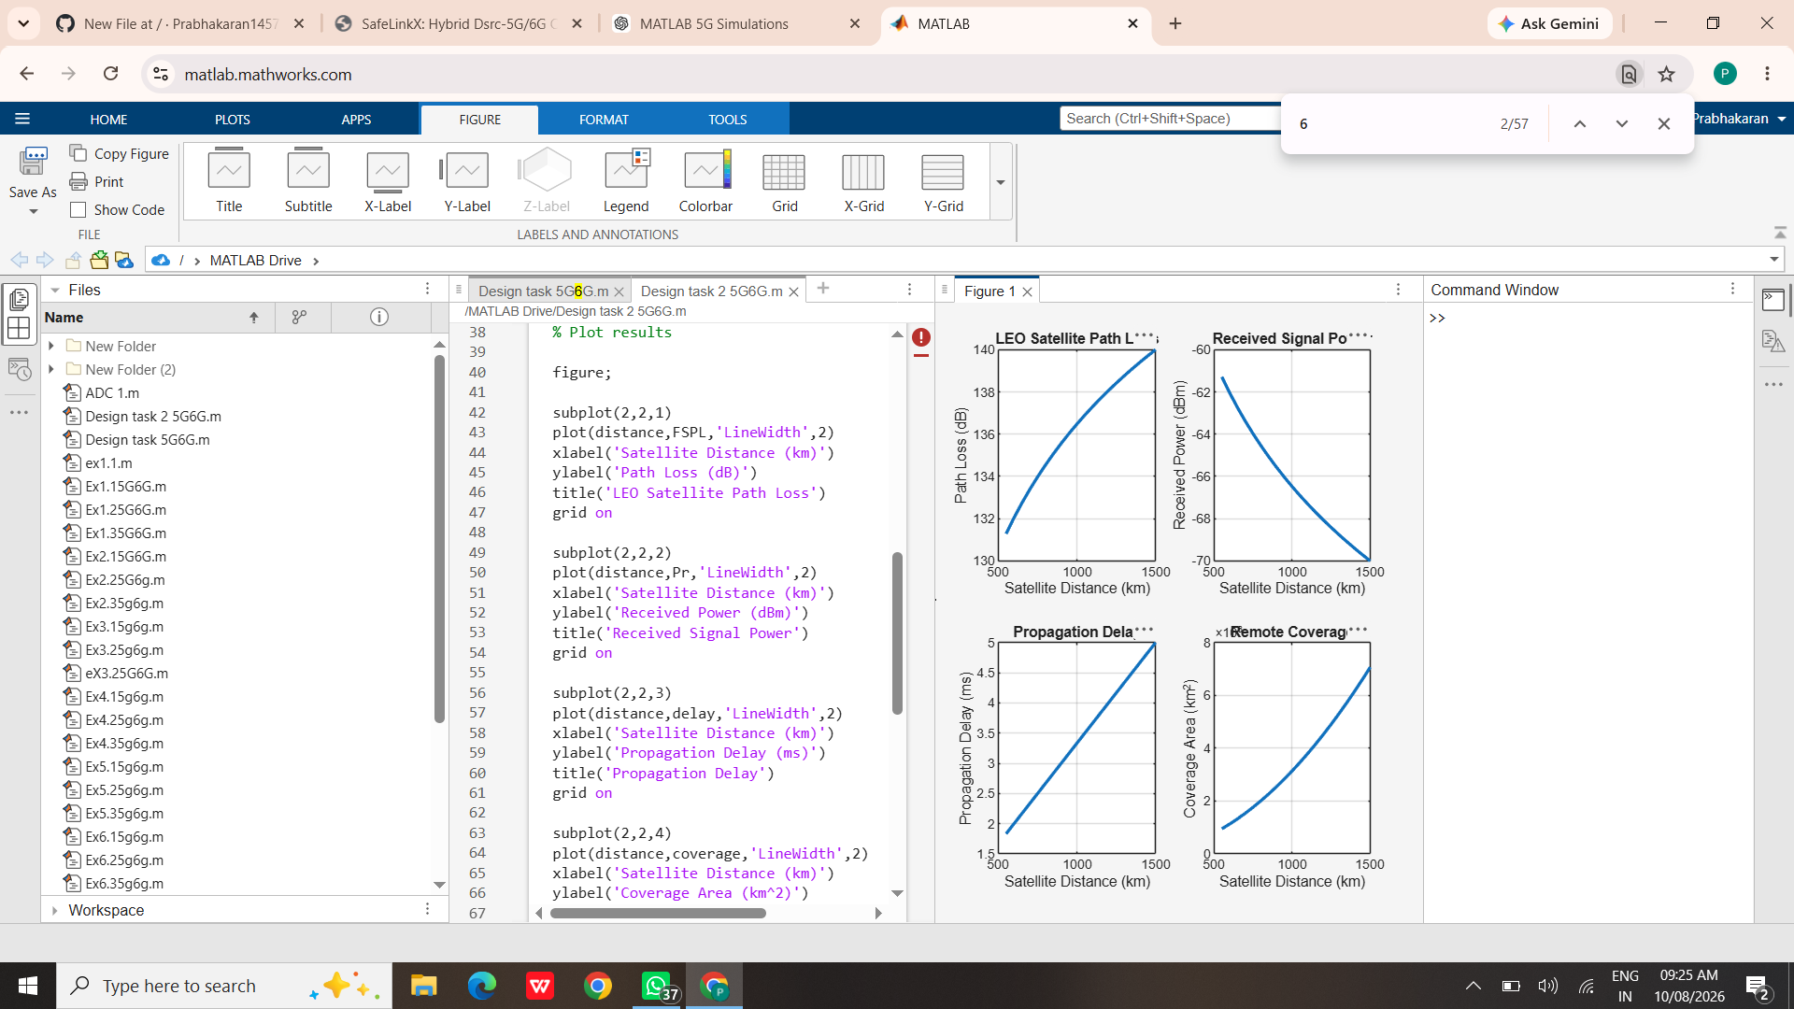
RESULT:
The LEO satellite-assisted communication model was successfully designed and simulated using MATLAB. The simulation showed that increasing the satellite-to-user distance increased propagation delay and path loss, resulting in lower received signal power. The model demonstrates how LEO satellites can provide wireless connectivity to remote areas where terrestrial networks are unavailable.

